2023 collection
ALOHA FRIDAYS EVENT DESIGN
___________________
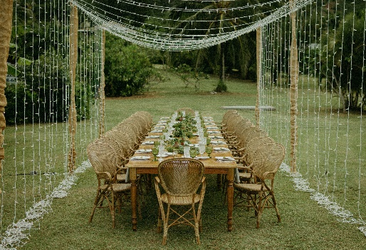 | 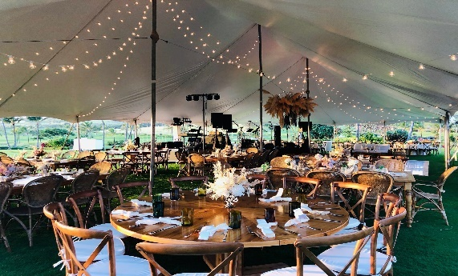 | 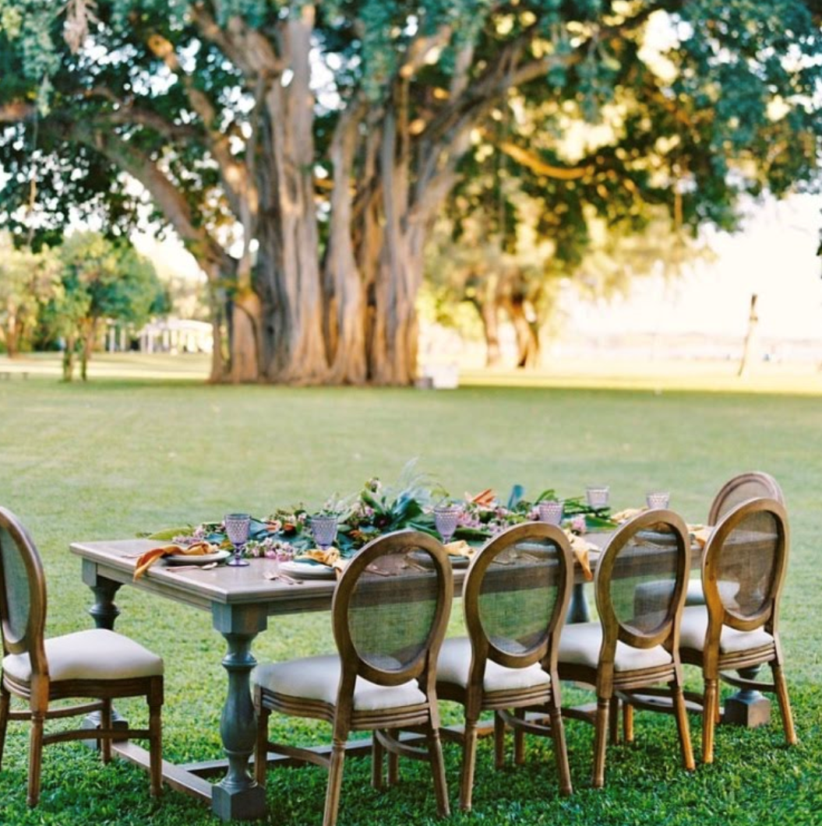
frances | CHRISTINA | JULIET
French Country Inspired, Rectangular Tables with a Honey Stain; Feminine, Turned Legs; Routed Edging Detail | Round, Cedar, Farm Tables with a Honey Stain; Chic Lines; Enhanced Wood Grains; Smooth Edges | Curvy & Bold with Extraordinary Routed Detail; Soft, Sandy Grey Stain
Dimensions 8’x4’  7 available/Seats 10  *depends on chair type | Dimensions 6’ Diameter  4 available/Seats 10  *depends on chair type | Dimensions 8’x4’  1 available/Seats 10  *Building More Fall 2022
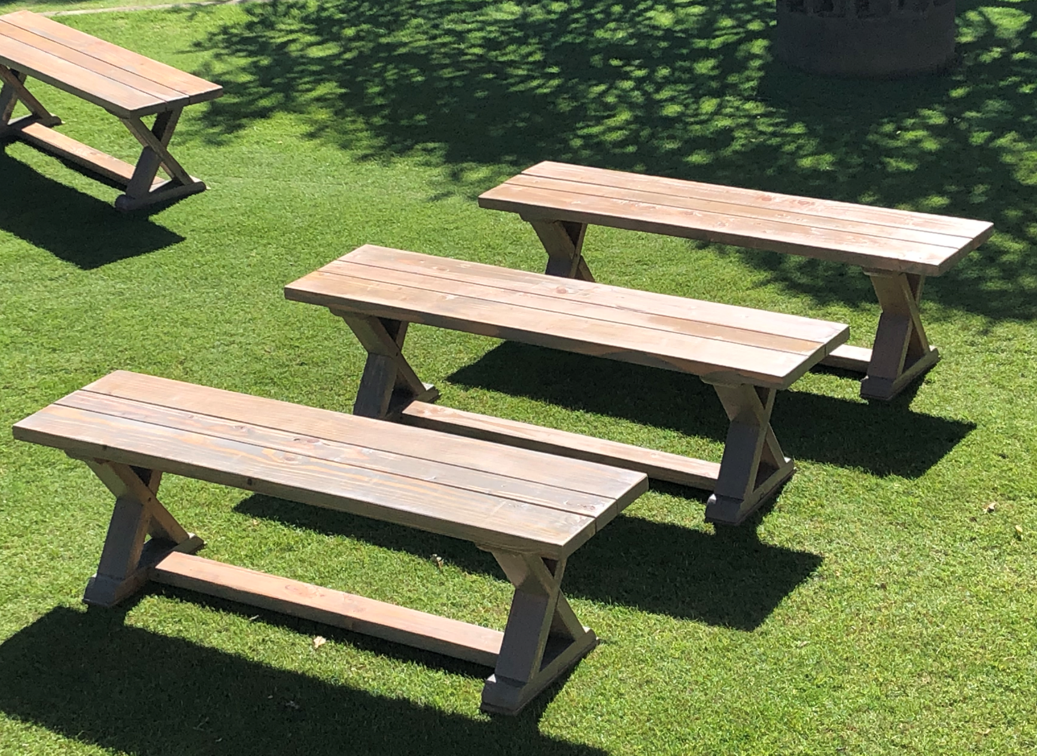 | 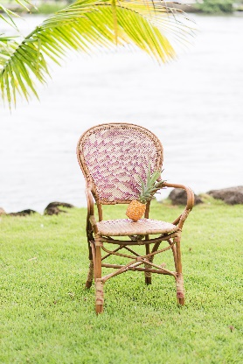 | 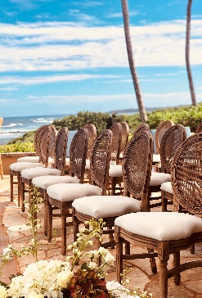
CHARLEY | GRACE | BEVERLY
Custom, Wood Benches with Sandy, Grey Stain; Strong, Tomboy Lines and a soft Touch; X Detailing on the Sides | Hand Woven Rattan; Charming, Elegant and Comfortable; the Perfect Balance of Sophistication & Simplicity | Upscale and Timeless, this chair is fit for a Queen; Mesh Rattan Back; Coordinates with  Every Look
Dimensions 5’ Long  Seats 3 adults comfortably  20 available | Dimensions W21.3”  60 available | Dimensions W19.5”  40 available

www.alohafridayskauai.com | 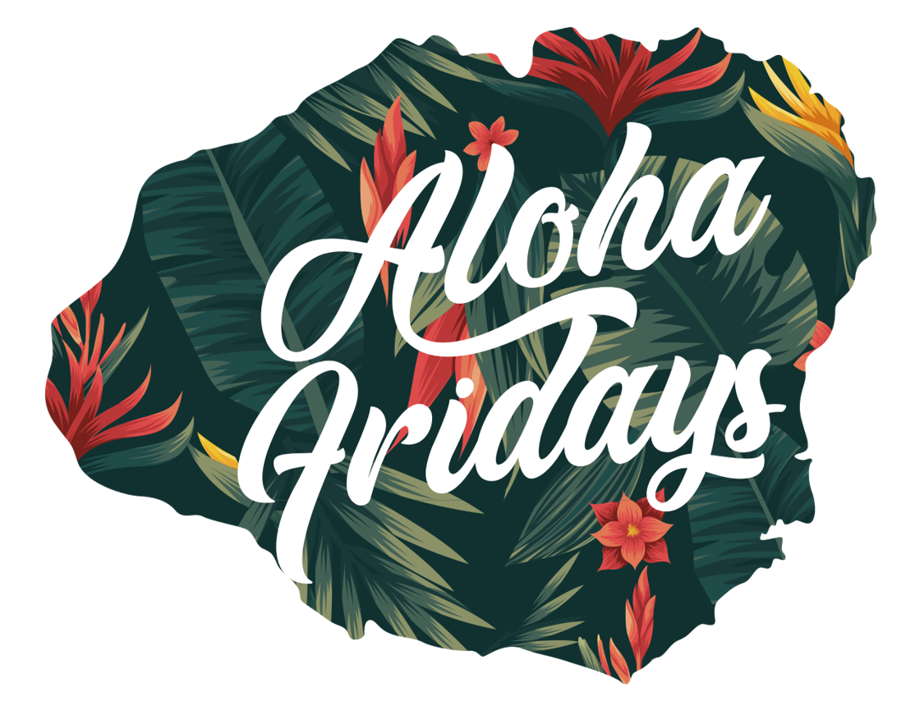 | Mona Garcia 808.631.6805

2023 collection
ALOHA FRIDAYS EVENT DESIGN
______________________
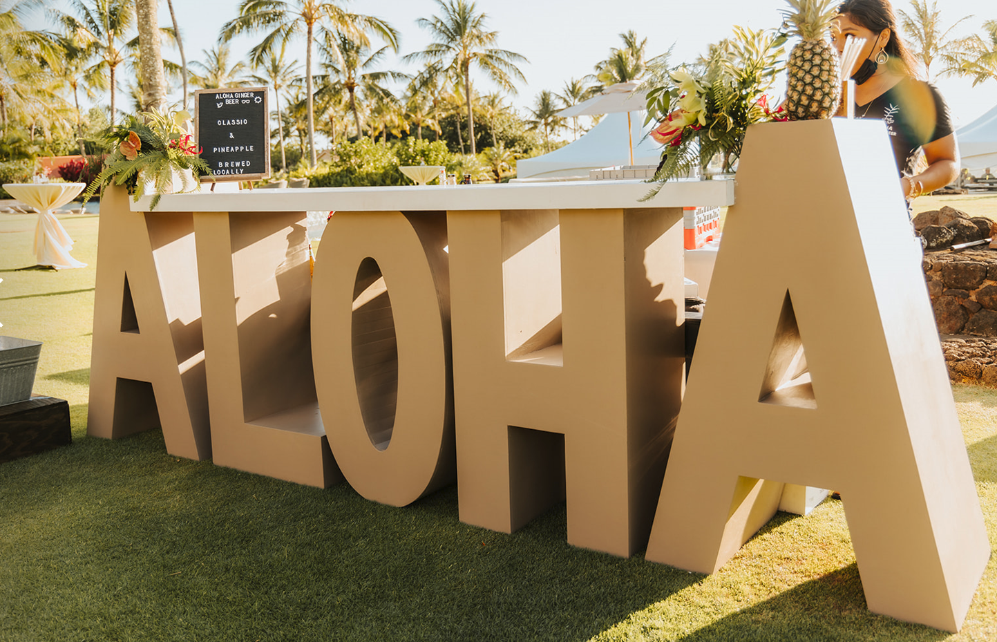 | 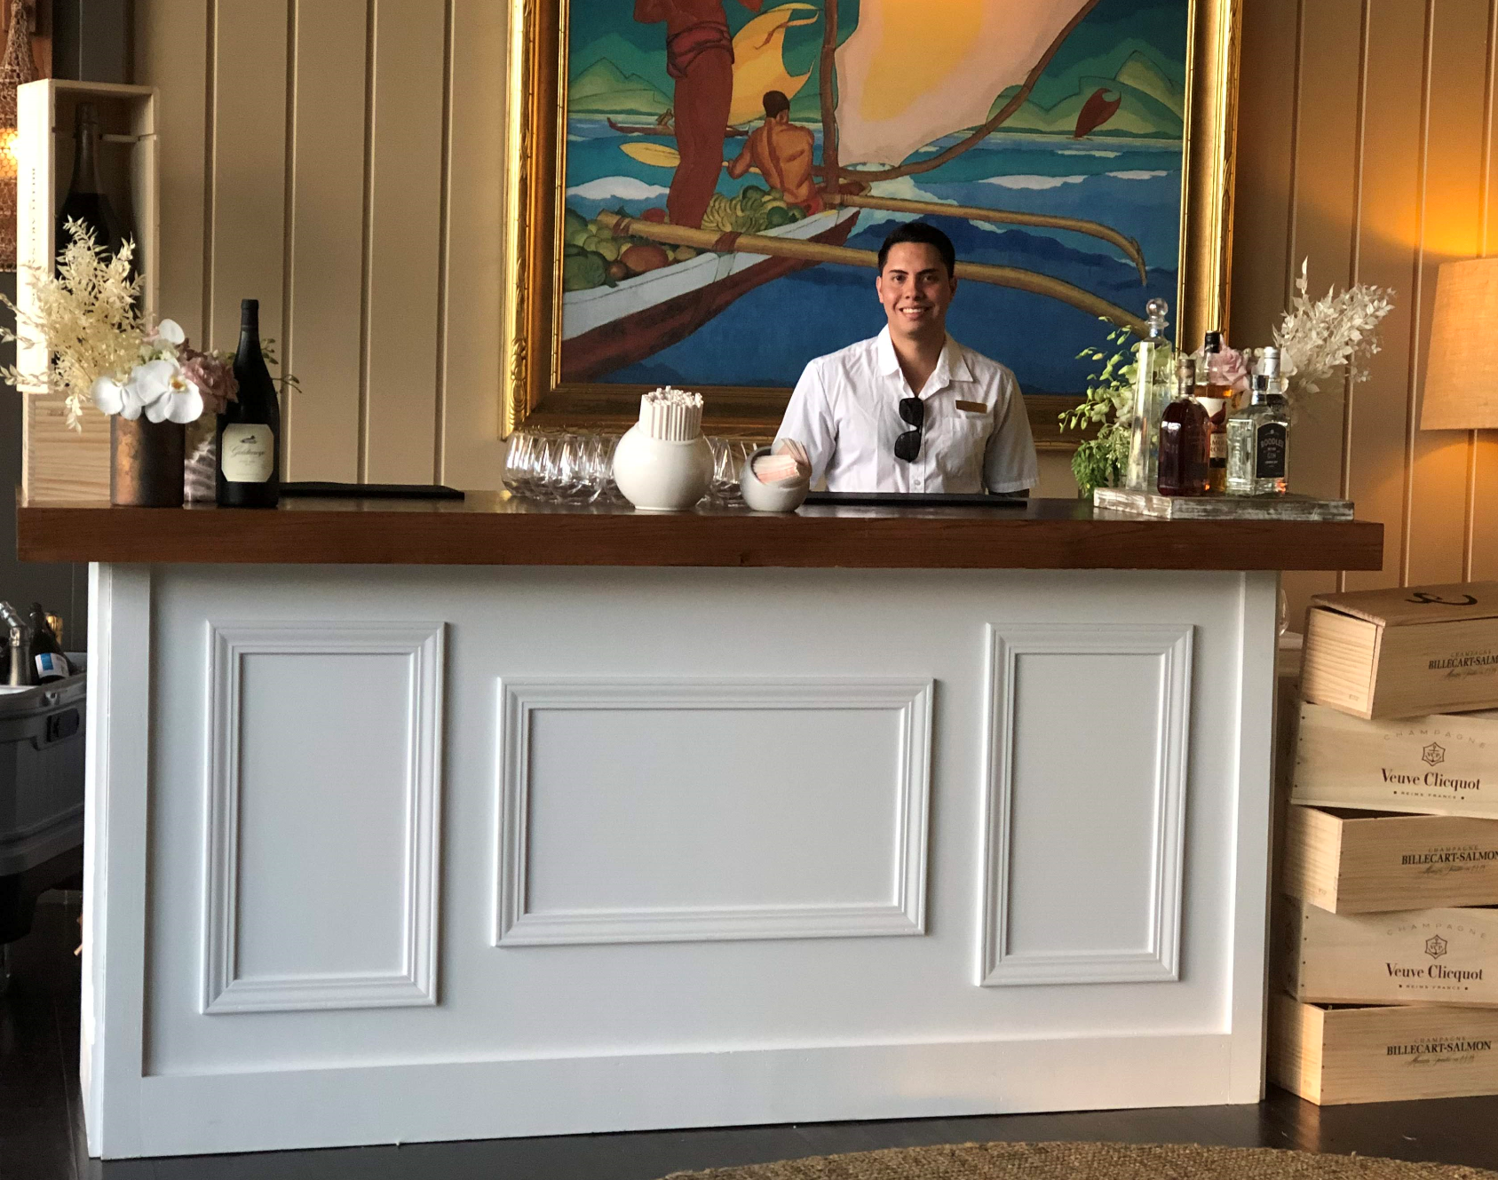 | 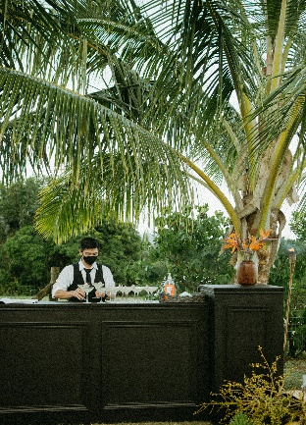
ALOHA BAR | WHITE BAR | BLACK VELVET
The Focal Piece for the Ultimate Celebration; Neutral in Color; Bold in Design; Also perfect for Dessert Displays/Welcome Table  *Recommend 1x6’ Banquet Table  for Bartender  Dimensions Usable Bar Top Length 8’/Entire Bar Length Top 10’; Bottom 11.6’  1 available | Super Clean Lines, Matte White Bar with Oak Top; Elegant Molding on Front and Sides; Shelving Included  *Recommend 1x6’ Banquet Table  for Bartender  Dimensions Bar Top 8’  Bar Base Length 7.1”  1 available | Strong Presence; Upscale Molding; Pillars for Added Drama; Velvety Smooth, Black Color  for the Bold and Daring  *Backdrop Available for Additional Rental Fee  *Recommend 1x6’ Banquet Table for Bartender  Dimensions Entire Length 10’  Pillars H49” W24”/each  Bar Top 6’ Across/ 1 available
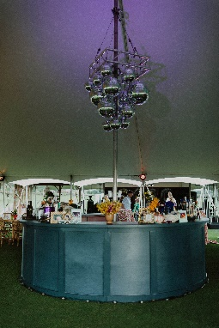 | 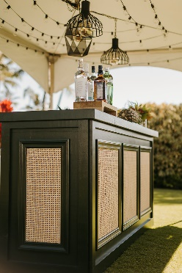 | 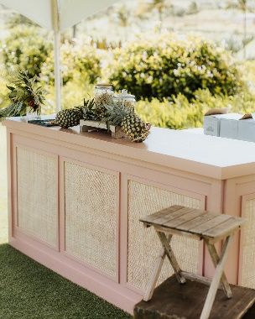
BETTY BLUE | HUNTER CANE BAR | ROSIE CANE BAR
The Round Bar! Main Focal & Gathering Area for the Night! Thick, Curvy, Ample Shelving, Navy Blue in Color  Diameter from Counter  to Counter 12’  Inside Diameter is 8’  Counter is 2’ Wide  1 available | Deep, Hunter Green Bar with Classic, Cane Webbing. Elegant in Design with a Vintage Touch, Shelving Included  *Recommend 1x6’ Banquet Table  for Bartender  Dimensions Bar Top 8’  Bar Base Length 7.1”  1 available | Dusty Pink in Color, Feminine and Soft with Modern Lines & Cane Webbing for an added Island Vibe, Shelving Included  *Recommend 1x6’ Banquet Table  for Bartender  Dimensions Bar Top 8’  Bar Base Length 7.1”  1 available

2023 collection
ALOHA FRIDAYS EVENT DESIGN
___________________
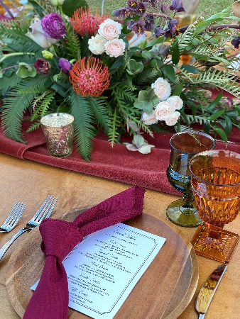 | 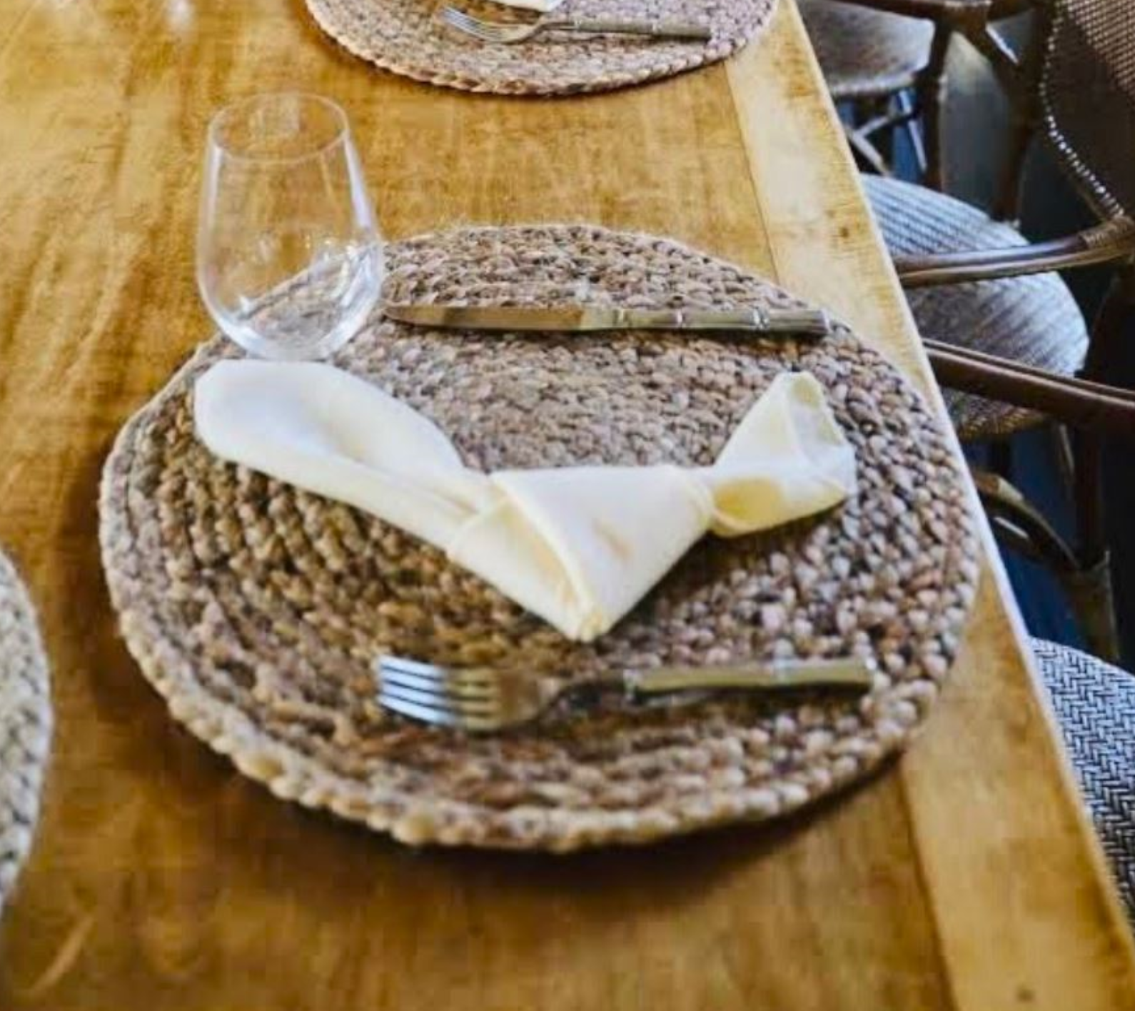 | 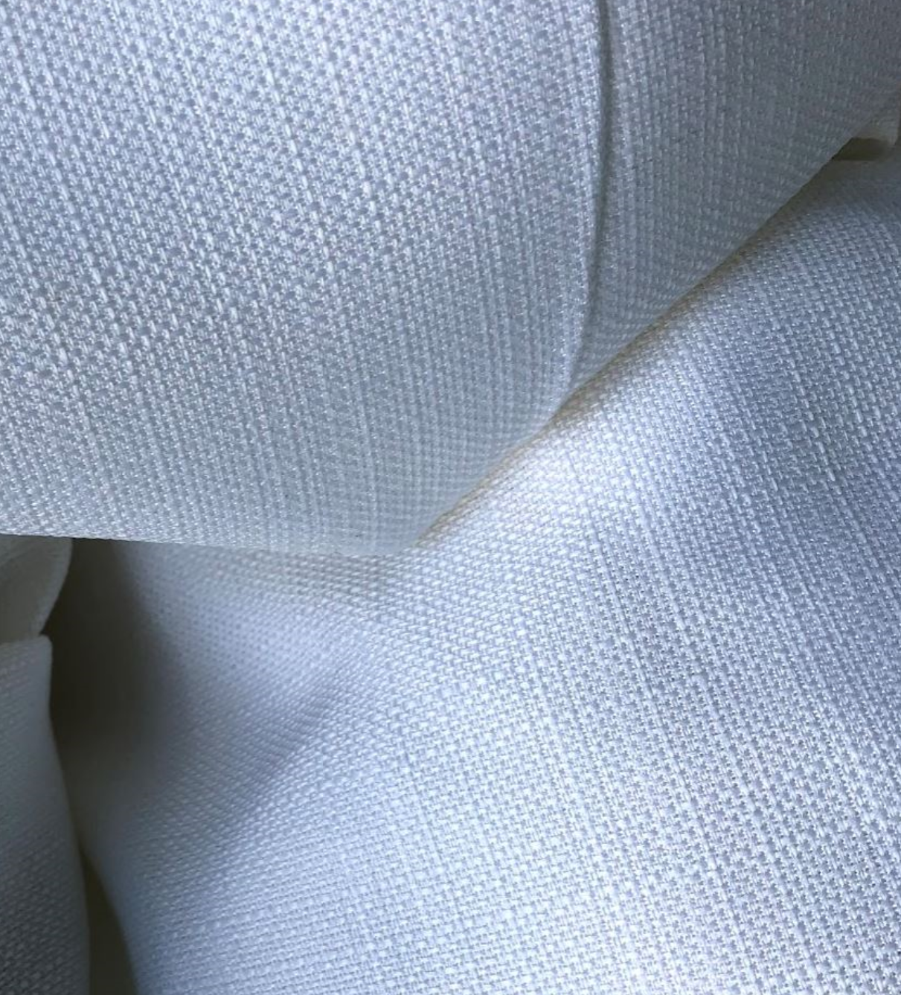
WOOD CHARGERS | JUTE PLACEMATS | NATURAL WHITE
Acacia Wood Chargers, Complements Every Aesthetic  Dimensions 10” Diameter  60 available | An added detail that will accent your table scape with simple elegance  Dimensions 15” Diameter  60 available | Woven Linens, Soft to the Touch  Dimensions Linens 132RD  8 Available  Dimensions Napkins 18”x18”  125 available
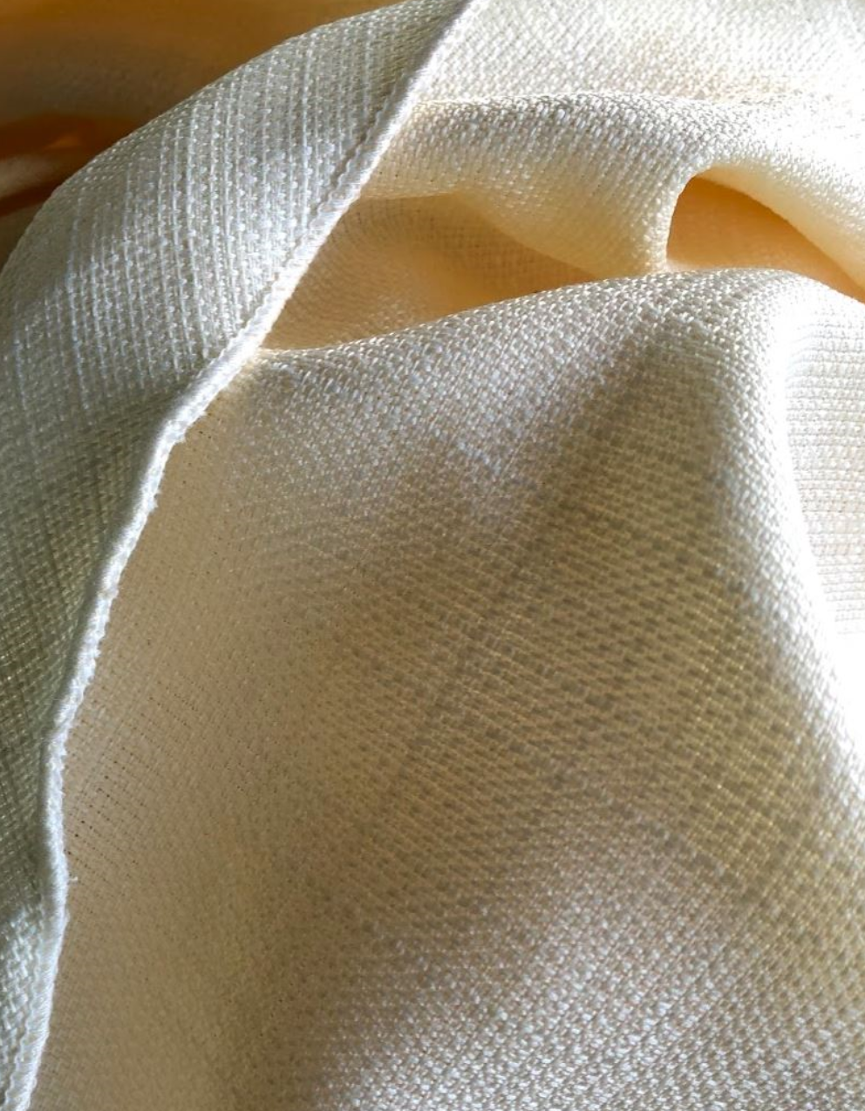 | 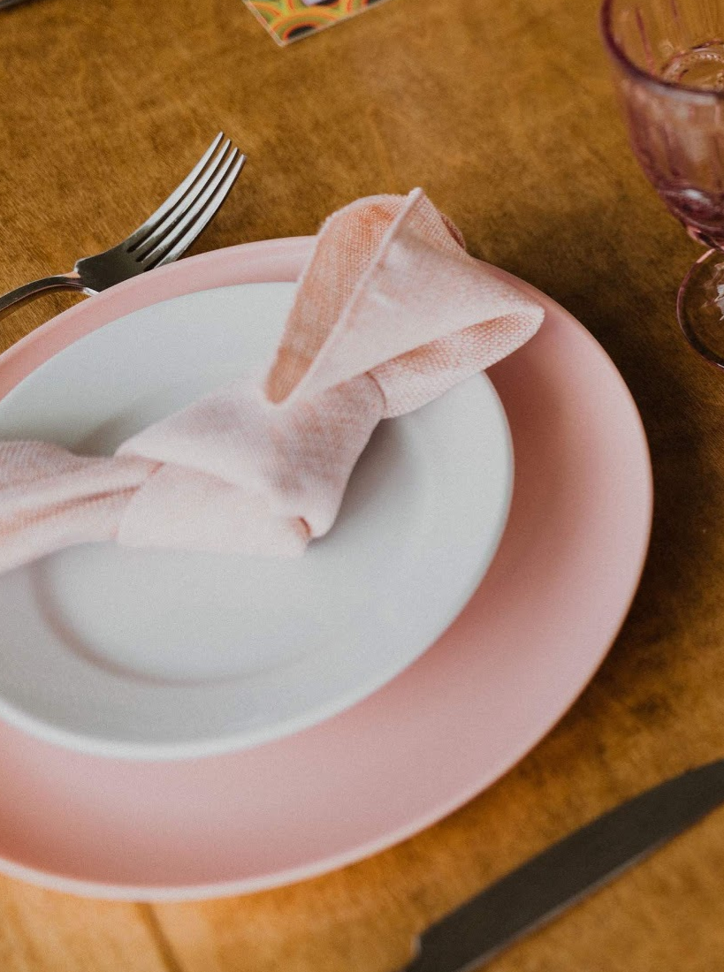 | 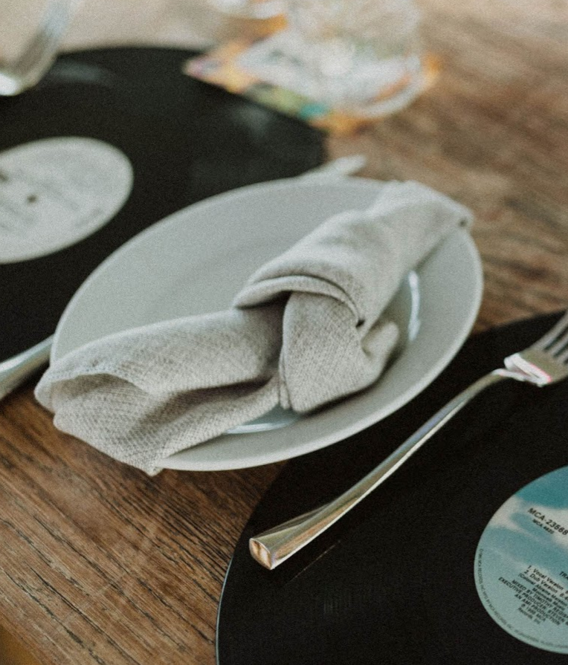
NATURAL IVORY | TEXTURED BLUSH | TEXTURED GREY
Woven Linens, Soft to the Touch | Woven Linens, Soft to the Touch  *Napkins Only | Woven Linens, Soft to the Touch  *Napkins Only
Dimensions Linens 132RD  10 Available  Dimensions Napkins 18”x18”  125 available | Dimensions Napkins 18”x18”  110 available | Dimensions Napkins 18”x18”  125 available

2023 collection
ALOHA FRIDAYS EVENT DESIGN
______________________

 | 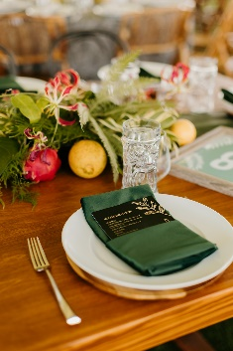 | 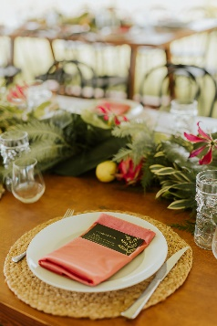
MAUVE VELVET | DARK GREEN VELVET | CORAL VELVET
Dimensions Napkins 18”x18”  60 available  *napkins only | Dimensions Napkins 18”x18”  60 available  *napkins only | Dimensions Napkins 18”x18”  60 available  *napkins only
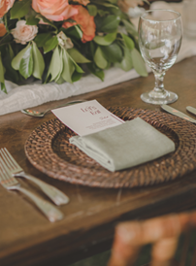 | 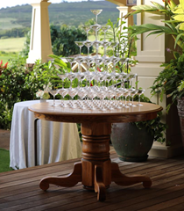 | 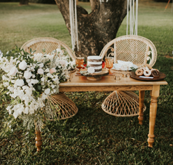
SAGE GREEN NAPKINS | MAKENA | HARMONY
Woven Linens, Soft to the Touch  *Napkins Only  Dimensions Napkins 18”x18”  100 available | Solid Oak Sweetheart Table with beautiful curves on her Pedestal Leg; also can be used for your Cake or Dessert Display  Dimensions 4’ Diameter  1 available | Beautifully, Hand Crafted Sweetheart Table for the Bride & Groom; also can be used for Cake/Dessert/Welcome Table & the perfect complement to our Frances Tables  *Specialty Chairs & Table Décor  Not Included  Dimensions 4’ x 2.5”  1 available

2023 collection
ALOHA FRIDAYS EVENT DESIGN
______________________

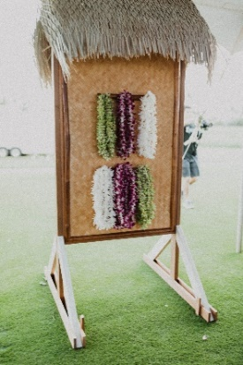 | 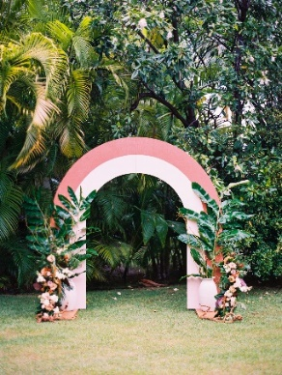 | 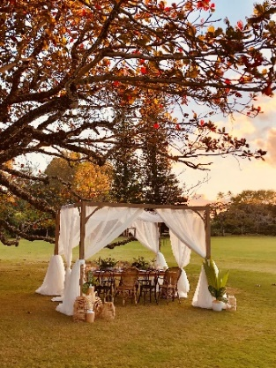
LEI STAND | RAINBOW ARCH | CABANA
What’s a perfect way to welcome your guests into your Reception than with a Lei Stand? Complete with Thatched Roof and Wooden Pegs  *Lei Not Included  Dimensions 7’ Tall  1 available | Playful in Design, Warm Pink Tones, a Great Option for a Wedding Arch or Backdrop  Dimensions 8’ Tall, 7.8” wide  1 available | Sandy, Grey Stain with Custom Corbel Designs, the Perfect Enhancement above your Dining or Lounge Area; Available with or without Draping  Available with or without  White Chiffon draping  Dimensions 10’x10’x8’  1 Available
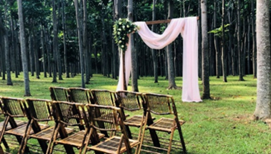 | 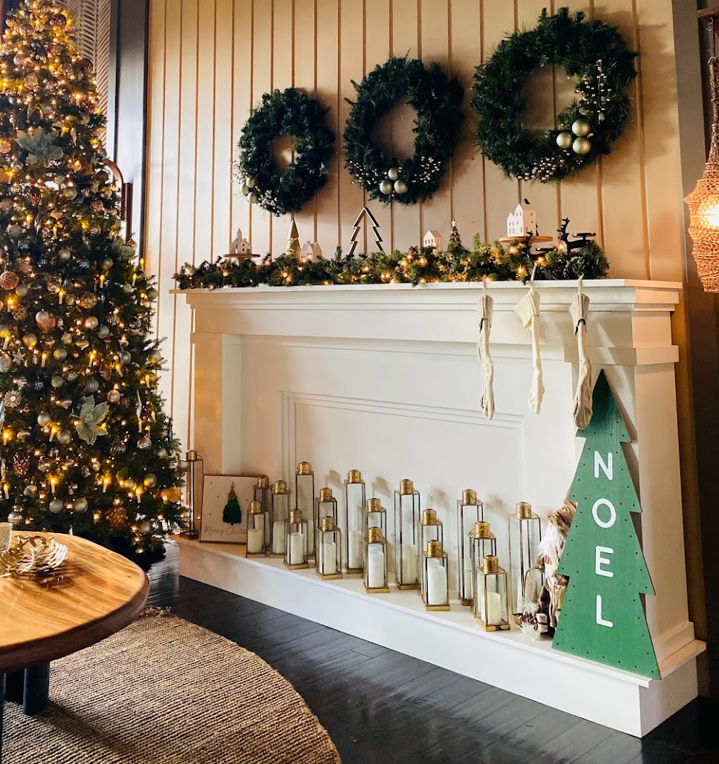
KELI’IKOA | FAUX FIREPLACE
2 Post Arch with a Dark, Wood Stain, Corbel Enhancements  Available with or without draping (depending on venue)  Dimensions 8’ Height  7’ Width between Posts  1 available | The Focal Piece for your Lounge Area or Backdrop; Elegant Molding, Soft White in Color & Grand in Design  *Not a Real Fireplace; Lanterns Not Included  Dimensions Usable Top Ledge 2.5’ wide/Entire Length 12’

